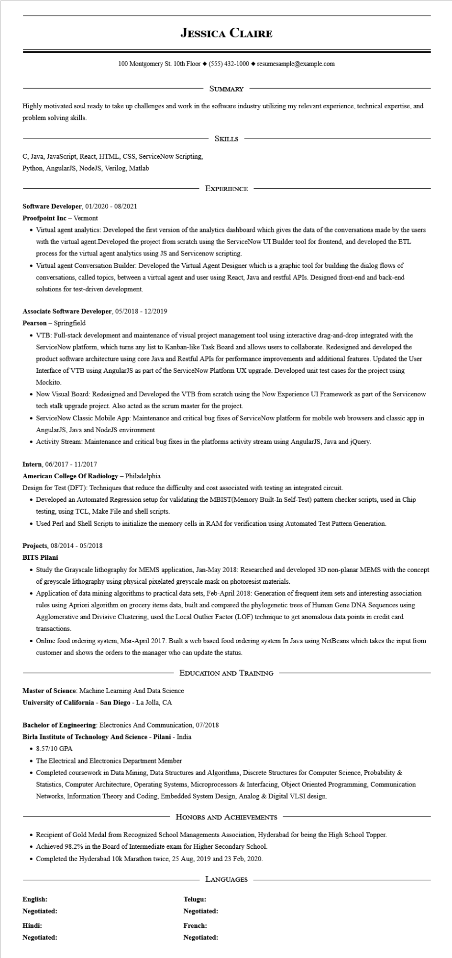
JESSICA CLAIRE
100 Montgomery St. 10th Floor (555) 432-1000◆ resumesample@example.com
SUMMARY
Highly motivated soul ready to take up challenges and work in the software industry utilizing my relevant experience, technical expertise, and problem solving skills.
C, Java, JavaScript, React, HTML, CSS, ServiceNow Scripting,
Python, AngularJS, NodeJS, Verilog, Matlab
SKILLS
EXPERIENCE
Software Developer, 01/2020 - 08/2021
Proofpoint Inc - Vermont
• Virtual agent analytics: Developed the first version of the analytics dashboard which gives the data of the conversations made by the users with the virtual agent.Developed the project from scratch using the ServiceNow UI Builder tool for frontend, and developed the ETL process for the virtual agent analytics using JS and Servicenow scripting.
• Virtual agent Conversation Builder: Developed the Virtual Agent Designer which is a graphic tool for building the dialog flows of conversations, called topics, between a virtual agent and user using React, Java and restful APIs. Designed front-end and back-end solutions for test-driven development.
Associate Software Developer, 05/2018 - 12/2019
Pearson Springfield
• VTB: Full-stack development and maintenance of visual project management tool using interactive drag-and-drop integrated with the ServiceNow platform, which turns any list to Kanban-like Task Board and allows users to collaborate. Redesigned and developed the product software architecture using core Java and Restful APIs for performance improvements and additional features. Updated the User Interface of VTB using AngularJS as part of the ServiceNow Platform UX upgrade. Developed unit test cases for the project using Mockito.
• Now Visual Board: Redesigned and Developed the VTB from scratch using the Now Experience UI Framework as part of the Servicenow tech stalk upgrade project. Also acted as the scrum master for the project.
• ServiceNow Classic Mobile App: Maintenance and critical bug fixes of ServiceNow platform for mobile web browsers and classic app in AngularJS, Java and NodeJS environment
• Activity Stream: Maintenance and critical bug fixes in the platforms activity stream using AngularJS, Java and jQuery.
Intern, 06/2017 - 11/2017
American College Of Radiology - Philadelphia
Design for Test (DFT): Techniques that reduce the difficulty and cost associated with testing an integrated circuit.
• Developed an Automated Regression setup for validating the MBIST(Memory Built-In Self-Test) pattern checker scripts, used in Chip testing, using TCL, Make File and shell scripts.
• Used Perl and Shell Scripts to initialize the memory cells in RAM for verification using Automated Test Pattern Generation.
Projects, 08/2014 - 05/2018
BITS Pilani
• Study the Grayscale lithography for MEMS application, Jan-May 2018: Researched and developed 3D non-planar MEMS with the concept of greyscale lithography using physical pixelated greyscale mask on photoresist materials.
• Application of data mining algorithms to practical data sets, Feb-April 2018: Generation of frequent item sets and interesting association rules using Apriori algorithm on grocery items data, built and compared the phylogenetic trees of Human Gene DNA Sequences using Agglomerative and Divisive Clustering, used the Local Outlier Factor (LOF) technique to get anomalous data points in credit card transactions.
• Online food ordering system, Mar-April 2017: Built a web based food ordering system In Java using NetBeans which takes the input from customer and shows the orders to the manager who can update the status.
EDUCATION AND TRAINING
Master of Science: Machine Learning And Data Science
University of California - San Diego - La Jolla, CA
Bachelor of Engineering: Electronics And Communication, 07/2018
Birla Institute of Technology And Science - Pilani - India
• 8.57/10 GPA
• The Electrical and Electronics Department Member
• Completed coursework in Data Mining, Data Structures and Algorithms, Discrete Structures for Computer Science, Probability & Statistics, Computer Architecture, Operating Systems, Microprocessors & Interfacing, Object Oriented Programming, Communication Networks, Information Theory and Coding, Embedded System Design, Analog & Digital VLSI design.
HONORS AND ACHIEVEMENTS
• Recipient of Gold Medal from Recognized School Managements Association, Hyderabad for being the High School Topper.
• Achieved 98.2% in the Board of Intermediate exam for Higher Secondary School.
• Completed the Hyderabad 10k Marathon twice, 25 Aug, 2019 and 23 Feb, 2020.
English:
Negotiated:
Hindi:
Negotiated:
LANGUAGES
Telugu: Negotiated:
French:
Negotiated:

